CentOS 6.2 installation:
BIOS Setup for Making the First Boot Priority as CD-ROM :

Power on the system and continuously press “Del” key the following “Bootup
Screen” will appear.

In the Main Menu it will show the connected devices like “Hard Disk and CD-
ROM”.Here itself we can easily identified whether the hardwares are being detected or not.

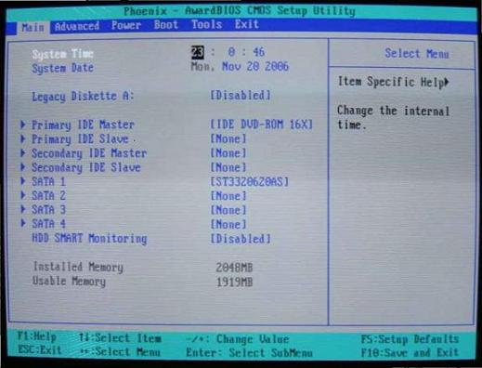

Then go to Boot Menu under the “Boot Menu” you set CD-ROM Boot Priority
as First.

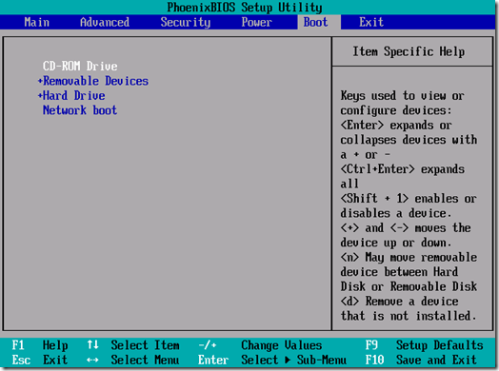

Press F10 then “Setup Configuration” window will appear.Here You choose Save Button
for saving your bootup configuration setup.

Exit ---> Discard Your Configuration Changes.

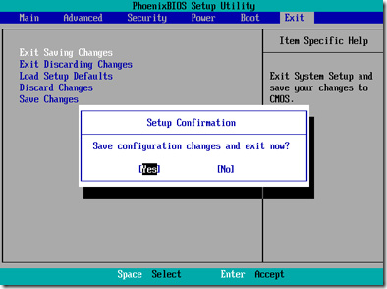

After make those configuration, the system will reboot automatically.

Installation Start

During Boot the Signal directly goes to CD-ROM.It will ask Press “Enter” Key to boot from CD-ROM. Here you Press Enter Key then installation start from CD automatically.There it will ask the installation options. Here you select “Install or upgrade on existing system” then press “Enter”.

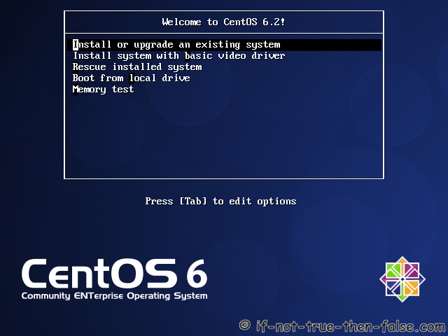

The following screen will appear during the centos kernal installation startup.

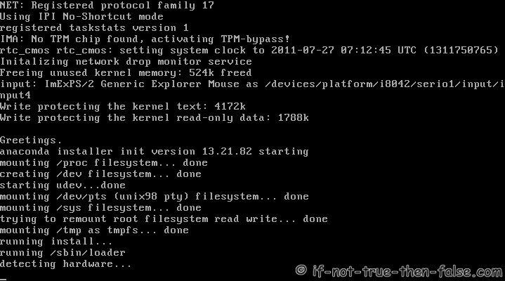

The following Screen will appear to test the “Media”. (CD TESTING).

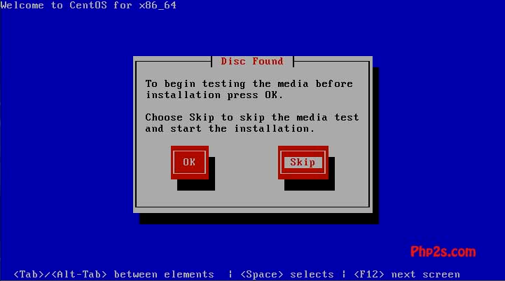

you choose “OK” for test your CD'S,otherwise you choose “SKIP”.

Here you choose “SKIP”.

It will ask the Installation Method for Installing CentOS. Here You Choose Installation method
as “LOCAL CD-ROM”.

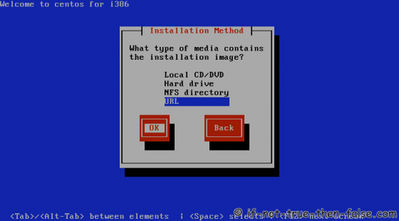

Retrieving install image:

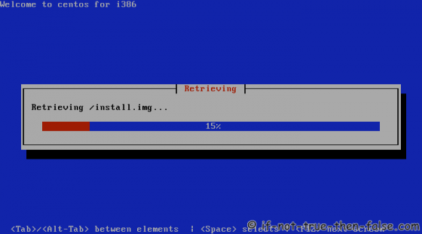

CentOS 6 Graphical Installer Starts
Now the installation start with GUI Mode.

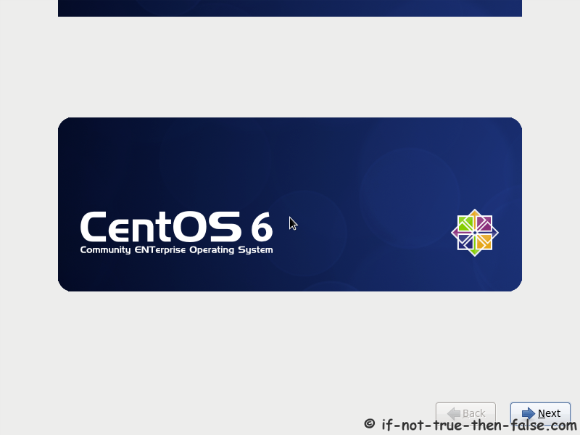

Here you Choose “Next” For proceeding next steps.

Select Your Language:
Then the following screen will appear for choosing language.Here you choose language as
“English”.

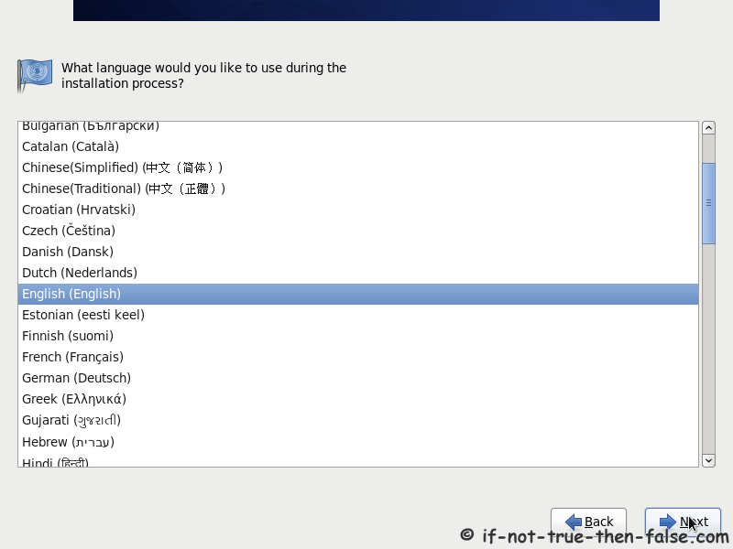

Select Keyboard Layout:

The Next Screen will appear for choosing the “Keyboard Type”. Here you choose the keyboard type as “US”.

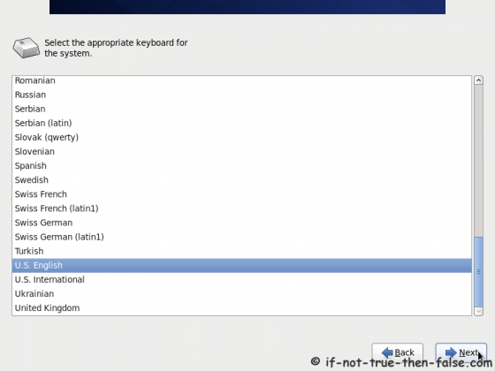

Select Storage Devices:
Here two type of devices available.we have to chose Basic strage Devices.

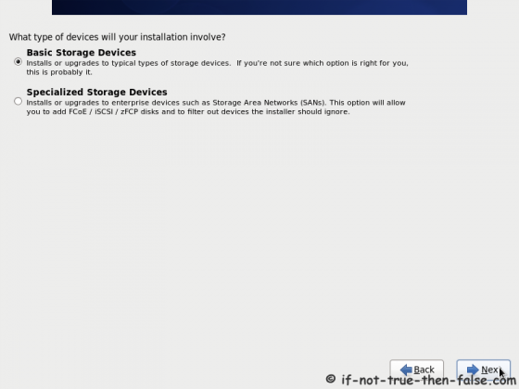

Set HostName:
Set the HOSTNAME in given “TEXTBOX”.Then click “NEXT” Button to continue the
Installation.

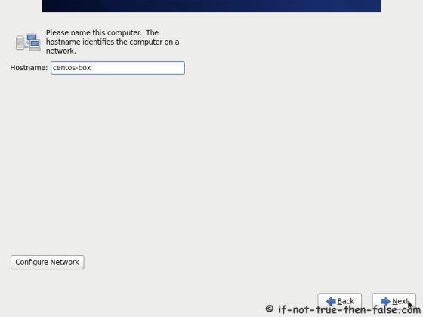

Select Timezone:
Here You choose your time zone as “Asia/Calcutta”.Then you press “Next” Button.

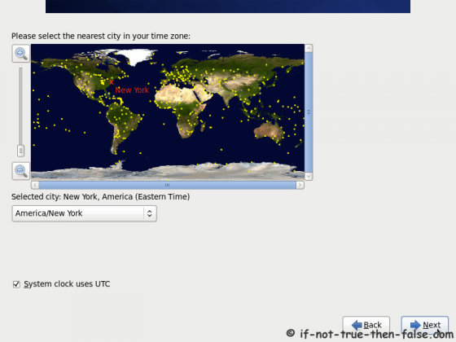

Set Root Password:

Here you set the password for “root” user login.Then you Click the “Next” button.

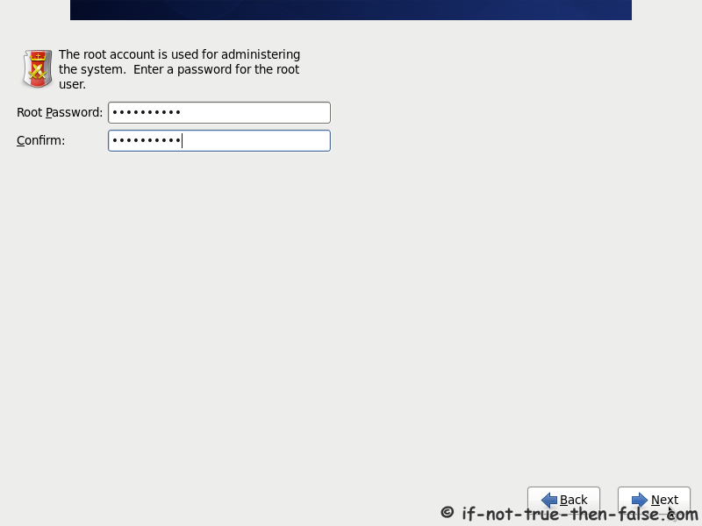

Select Type of Installation:

The following screen will ask the Partitioning of your harddisk.

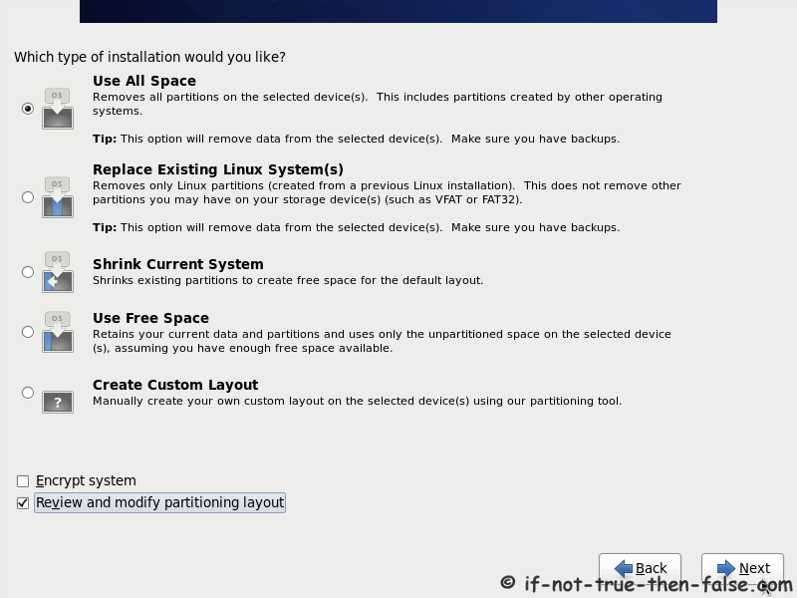

Here You choose “Create Custom Layout” for Partitioning of your harddisk as per your
requirement. Then Click “Next” button for creating partition.

Check (and modify) Partition setup

Here you have different option for managing your hard disk with partition.

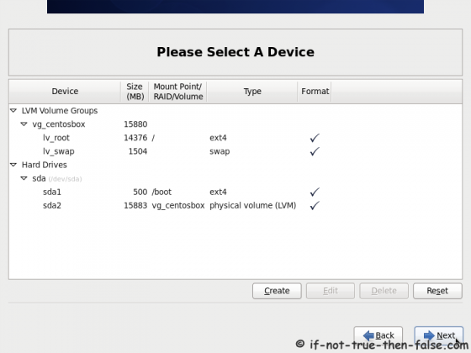

New -->Create a new partition.
Edit -->To modified the Partition.
Delete --> Delete the Partition.
Reset --> It used to Reset the Partition settings to Exiting one.
Raid --> It is used to create the “RAID Partition”.
Lvm --> It is used to create the “LVM Partition”.
Create the partition as per your requirement using the above mention options.Then you
give “Next” button to proceed the installation.

Write Changes to Disk:
Select “Write changed to disk” then it will make the partition as per your requirement.

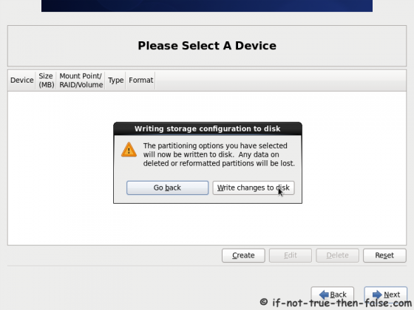

Then Choose “Next” button.

Configure Boot Loader:
The following screen will shows the GRUB BOOT LOADER installation

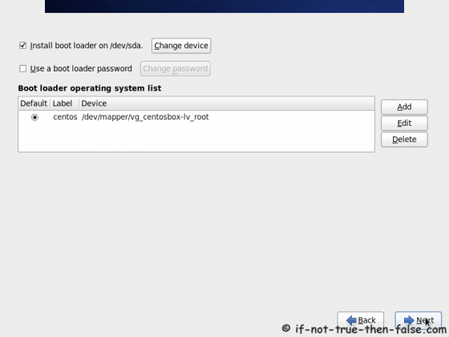

You use more than one hard disk means , that time you choose which hard disk you want to
load the “GRUB BOOT LOADER”.

Customize Package Selection:

The following screen used to install the necessary needed package installation selection.

Here we have two options like

1.Customize Later -- Used to install the necessary packages after installation of OS.
This can be done through “RPM” or “YUM” Installation method.
2. Customize Now – Used to install the necessary packages during installation of OS.

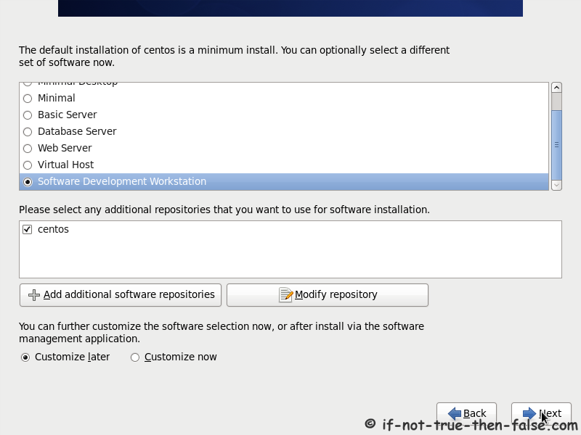
Here you choose “Customize Now” .Then you click the “NEXT” button to select the
necessary package.

Installation Started:

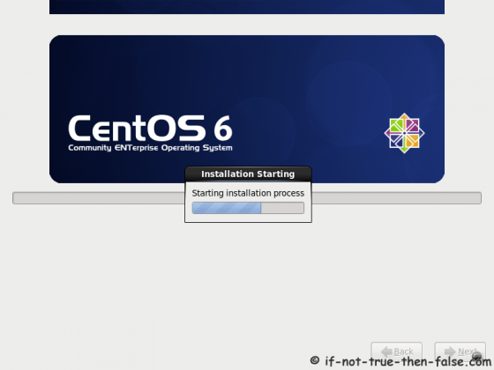

CentOS 6.2 Installation Completed
The installation is finished.

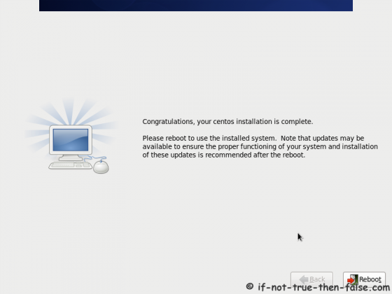

Here You Click the “Reboot” Button for reboot your system.

Note: Before Rebooting your system remove your installation media's.(Cds).

Booting CentOS 6.2



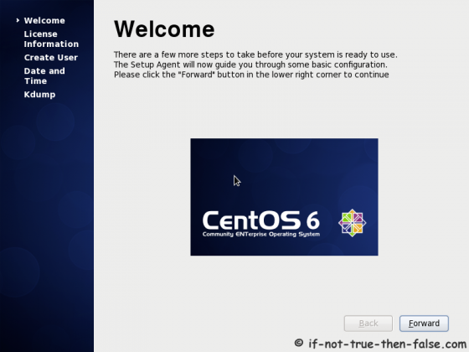
WELCOME SCREEN:

Accept CentOS License Agreement:
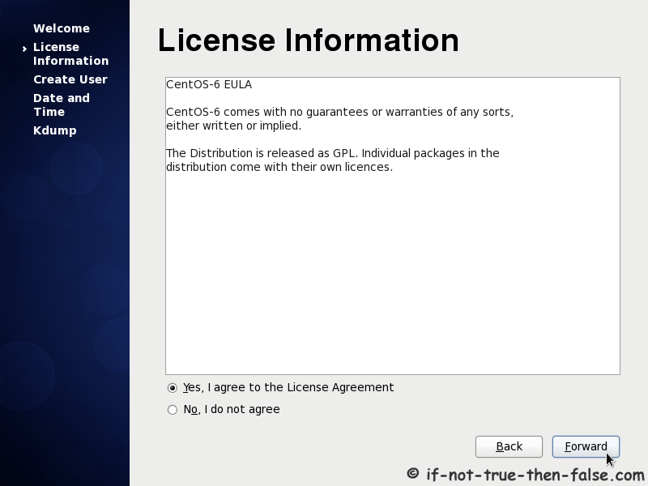

Click “Forward” button to proceed the next steps of configuration.

Create User:

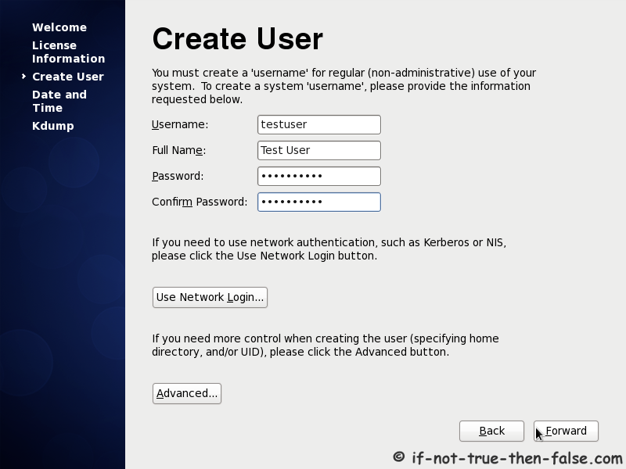

Create the “New User” and set the password also.

Set Date And Time:

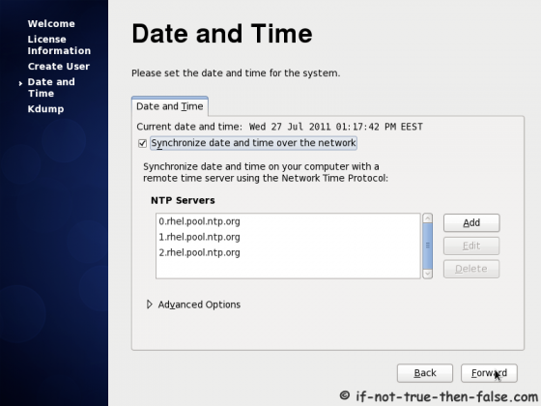

Here You set the system date and time.

User Login:

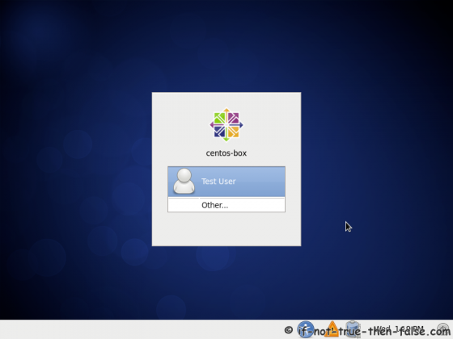

Here you enter the user login details.

Successful Login :

